CIS2275 C++ Programming Part II
Program 4 Simple Calculator on a Windows Form
Objective: Write a simple class and implement a Windows Form application

Turn In Requirements:
- 5 pts Name your Visual C++ 2019 project LastnameP4, such as NelsonP4.
- 5 pts Upload your project to Brightspace, remove the intermediate files/ folders from your project before uploading it to Brightspace.

Program Requirements:
- 3 pts Write your name, email address and file name at the top of your source code in a comment.
- 5 pts Your form should have the abbreviated “header” information on its title. The header info includes your name, course and program information.
- 5 pts. Use good C++ programming style and formatting for your program. Use appropriate comments to explain what you are doing.

This is our introduction to Windows forms. We will learn about the visual side of VS 2019 by programming a calculator.

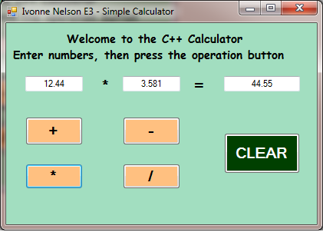
We will build this form together in the lab.

We will learn to convert the .NET String is retrieved from the textboxes into primitives that we can use.

We will then use our native C++ class to “power” the calculator on the form.

We will also learn to format our output on the form so that our results will be displayed with two decimal places of precision.

You have already written the SimpleCalc class. Here are the modifications to be made in the .cpp file: When returning the formatted string, you will convert the double answer to the string the result. You will set the result into the appropriate textbox on the form. For the case of dividing by 0, you will return a message, which will be a string that will be assigned to result.

At the top of the form1.h, add #include "SimpleCalc.h". Create an instance of SimpleCalc on the form just above the declaration of public ref class MyForm : etc.

For the form, you will have 3 text boxes, two for the user’s numerical input and one to display the answer (or result). You will have 4 buttons, one for each type of operation. There will be an additional button, Clear. In the event handler for the Clear button, clear the text boxes and operation label so your form is reset. You will have labels which will present the title and describe the program input required from the user, and 2 labels which will appear to make an “equation” on the form. Put your name and Program title in the Text property of Form1.
Exceptions: We will also learn to spot where an exception may occur and how to handle it. The methods used for parsing Strings to numeric types in C# are: double result = Convert:: ToDouble(string )
double result = Double.Parse(string)

These two methods throw 3 or 4 exceptions: ArgumentNullException (blank textbox) , OverflowException (number too small or too large for numeric range) ,FormatException(not a number of the correct type) and
ArgumentException(one of the passed arguments is not of the correct type)
Convert only throws 3 because it returns 0 instead of an ArgumentNullException.
We can list the exceptions by type in three or four catches or we can simply catch Exception.

